# CS 340 Project Two README Template

# Nevena Young

# 10/20/2024

## Global Rain

My team was assigned to work on a project for an innovative international rescue -animal training company, called Grazioso Salvare. We need to create a user-friendly interactive screen to search for dogs that fit a certain criterion.

## Motivation

The company Grazioso Salvare needs this so they can categorize the animals/dogs by breed, age, and gender. This is so they can know what animals they can train.

## Getting Started

First, we need to import the databases we will be using. This allows us to access the stored information.

## Installation

Once we’ve imported the databases, we will be able to use the said information. This is the PY file we will be using for the user side. This shows the saved details that we can use.

## Usage

This is the PY file we use to add, edit, or delete entered information. This process is called CRUD.

This part is so the user can access saved information from the PY file.

This part shows the logo for Grazioso Salvare and the categorizes for the different types of training.

This shows the output of the above code.

The next two screenshots will show how we code the table and the output of the table.

This shows how we hardcode the results for the categories.

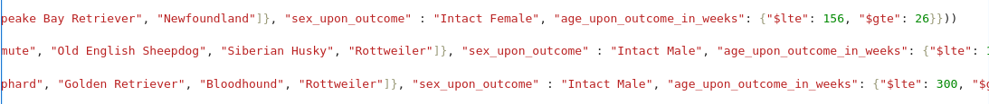

This shows the graph and the percentage of the animals/breeds.

This is the map that shows the location of the animal.

## Contact

Your name: Nevena Young